UNIVERSITY OF WAH (UOW)

DEPARTMENT OF COMPUTER SCIENCE



BSCS 3RD B

REG #: UW-24-CS-BS-088

SUBMITTED BY: SAADI SAFDAR

SUBMITTED TO: Ms. MUNNIBA KHAN

COURSE TITLE: DATA STRUCTURES

COURSE CODE: CS – 201 L

LAB REPORT # 10

Lab Task: Scenario University Admission Processing System
Background
During university admission days, a large number of students visit the admission office to submit
documents and get verification done. Since only one student can be processed at a time, students
must be handled in the exact order in which they arrive.
To ensure fairness and proper management, the admission office follows a First Come First
Serve (FCFS) policy.
Problem Statement
Design a system that manages students waiting for admission processing such that:
• Students are served in the order they arrive.
• The first student in the line is processed first.
• The system can display the current student being served.
• The total number of waiting students can be tracked efficiently.
Why Queue is Used
Queue follows FIFO, which perfectly matches the admission process:
• First student entering the queue → First student processed.
Functional Requirements
1. Add a new student to the waiting list.
2. Remove a student once admission processing is completed.
3. Display the student currently being served.
4. Display total number of students waiting.
Queue Operations Mapping
Admission Requirement | Queue Operation
Student arrives | Enqueue
Student processed | Dequeue
Current student | Front
Waiting students | Count
Efficient space usage | Circular Queue

Queue Implementations Used
• Array Queue → Limited daily admissions
• Linked List Queue → Unlimited students
• Circular Queue → Efficient memory usage
• Circular Queue with Count → Track waiting students

Array Queue:

#include <iostream>
using namespace std;

#define SIZE 5
string queueArr[SIZE];
int frontArr = -1, rearArr = -1;

void enqueueArr(string name) {
if (rearArr == SIZE - 1) {
cout << "Queue Overflow (daily limit reached)\n";
return;
}
if (frontArr == -1) frontArr = 0;
queueArr[++rearArr] = name;
cout << "Student added: " << name << endl;
}

void dequeueArr() {
if (frontArr == -1 || frontArr > rearArr) {
cout << "Queue Underflow (no student to process)\n";
return;
}
cout << "Student processed: " << queueArr[frontArr++] << endl;
}

void currentStudentArr() {
if (frontArr == -1 || frontArr > rearArr)
cout << "No current student\n";
else
cout << "Current student: " << queueArr[frontArr] << endl;
}

void countArr() {
if (frontArr == -1 || frontArr > rearArr)
cout << "Total waiting students: 0\n";
else
cout << "Total waiting students: " << (rearArr - frontArr + 1) << endl;
}

void displayArr() {
if (frontArr == -1 || frontArr > rearArr) {
cout << "Queue Empty\n";
return;
}
cout << "Waiting students: ";
for (int i = frontArr; i <= rearArr; i++) {
cout << queueArr[i] << " ";
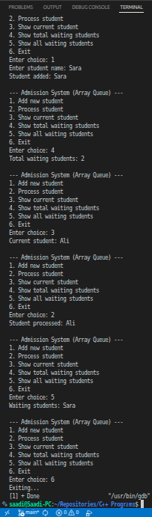
}
cout << endl;
}

int main() {
int choice;
string name;

do {
cout << "\n--- Admission System (Array Queue) ---\n";
cout << "1. Add new student\n";
cout << "2. Process student\n";
cout << "3. Show current student\n";
cout << "4. Show total waiting students\n";
cout << "5. Show all waiting students\n";
cout << "6. Exit\n";
cout << "Enter choice: ";
cin >> choice;

switch (choice) {
case 1:
cout << "Enter student name: ";
cin >> name;
enqueueArr(name);
break;
case 2:
dequeueArr();
break;
case 3:
currentStudentArr();
break;
case 4:
countArr();
break;
case 5:
displayArr();
break;
case 6:
cout << "Exiting...\n";
break;
default:
cout << "Invalid choice\n";
}
} while (choice != 6);

return 0;
}

Linked List Queue:

#include <iostream>
using namespace std;

struct node {
string name;
node* link;
};

class queue_list {
node *front, *rear;
public:
queue_list() {
front = rear = NULL;
}

void enqueue(string student) {
node *tmp = new node;
tmp->name = student;
tmp->link = NULL;

if (front == NULL)
front = rear = tmp;
else {
rear->link = tmp;
rear = tmp;
}
cout << "Student added: " << student << endl;
}

void dequeue() {
if (front == NULL) {
cout << "Queue Underflow (no student to process)\n";
return;
}
node *tmp = front;
cout << "Student processed: " << tmp->name << endl;
front = front->link;
delete tmp;
if (front == NULL) rear = NULL;
}

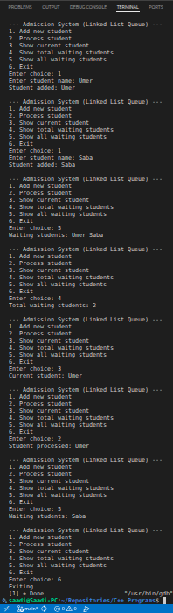
void currentStudent() {
if (front == NULL)
cout << "No current student\n";
else
cout << "Current student: " << front->name << endl;
}

void countWaiting() {
int cnt = 0;
node *ptr = front;
while (ptr != NULL) {
cnt++;
ptr = ptr->link;
}
cout << "Total waiting students: " << cnt << endl;
}

void displayAll() {
if (front == NULL) {
cout << "Queue Empty\n";
return;
}
cout << "Waiting students: ";
node *ptr = front;
while (ptr != NULL) {
cout << ptr->name << " ";
ptr = ptr->link;
}
cout << endl;
}
};

int main() {
queue_list q;
int choice;
string name;

do {
cout << "\n--- Admission System (Linked List Queue) ---\n";
cout << "1. Add new student\n";
cout << "2. Process student\n";
cout << "3. Show current student\n";
cout << "4. Show total waiting students\n";
cout << "5. Show all waiting students\n";
cout << "6. Exit\n";
cout << "Enter choice: ";
cin >> choice;

switch (choice) {
case 1:
cout << "Enter student name: ";
cin >> name;
q.enqueue(name);
break;
case 2:
q.dequeue();
break;
case 3:
q.currentStudent();
break;
case 4:
q.countWaiting();
break;
case 5:
q.displayAll();
break;
case 6:
cout << "Exiting...\n";
break;
default:
cout << "Invalid choice\n";
}
} while (choice != 6);

return 0;
}

Circular Queue:

#include <iostream>
using namespace std;

#define SIZE 5
string cqueue[SIZE];
int frontCQ = -1, rearCQ = -1;

void enqueueCQ(string name) {
if ((rearCQ + 1) % SIZE == frontCQ) {
cout << "Queue Full\n";
return;
}
if (frontCQ == -1) frontCQ = 0;
rearCQ = (rearCQ + 1) % SIZE;
cqueue[rearCQ] = name;
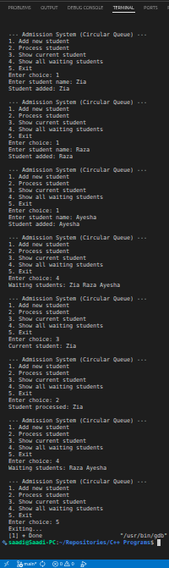
cout << "Student added: " << name << endl;
}

void dequeueCQ() {
if (frontCQ == -1) {
cout << "Queue Empty\n";
return;
}
cout << "Student processed: " << cqueue[frontCQ] << endl;
if (frontCQ == rearCQ)
frontCQ = rearCQ = -1;
else
frontCQ = (frontCQ + 1) % SIZE;
}

void displayCQ() {
if (frontCQ == -1) {
cout << "Queue Empty\n";
return;
}
cout << "Waiting students: ";
int i = frontCQ;
while (i != rearCQ) {
cout << cqueue[i] << " ";
i = (i + 1) % SIZE;
}
cout << cqueue[i] << endl;
}

void currentStudentCQ() {
if (frontCQ == -1)
cout << "No current student\n";
else
cout << "Current student: " << cqueue[frontCQ] << endl;
}

int main() {
int choice;
string name;

do {
cout << "\n--- Admission System (Circular Queue) ---\n";
cout << "1. Add new student\n";
cout << "2. Process student\n";
cout << "3. Show current student\n";
cout << "4. Show all waiting students\n";
cout << "5. Exit\n";
cout << "Enter choice: ";
cin >> choice;

switch (choice) {
case 1:
cout << "Enter student name: ";
cin >> name;
enqueueCQ(name);
break;
case 2:
dequeueCQ();
break;
case 3:
currentStudentCQ();
break;
case 4:
displayCQ();
break;
case 5:
cout << "Exiting...\n";
break;
default:
cout << "Invalid choice\n";
}
} while (choice != 5);

return 0;
}

Circular Queue with Count:
#include <iostream>
using namespace std;

#define SIZE 5
string queueCQ[SIZE];
int frontC = 0, rearC = -1, countC = 0;

void enqueueC(string name) {
if (countC == SIZE) {
cout << "Queue Full\n";
return;
}
rearC = (rearC + 1) % SIZE;
queueCQ[rearC] = name;
countC++;
cout << "Student added: " << name << endl;
}

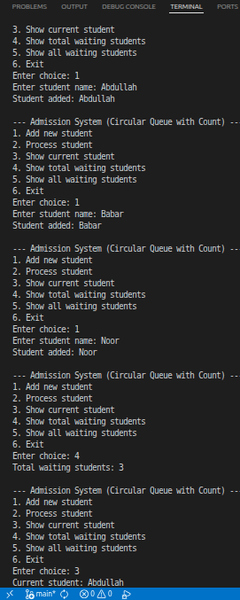
void dequeueC() {
if (countC == 0) {
cout << "Queue Empty\n";
return;
}
cout << "Student processed: " << queueCQ[frontC] << endl;
frontC = (frontC + 1) % SIZE;
countC--;
}

void displayC() {
if (countC == 0) {
cout << "Queue Empty\n";
return;
}
cout << "Waiting students: ";
int i = frontC;
for (int c = 0; c < countC; c++) {
cout << queueCQ[i] << " ";
i = (i + 1) % SIZE;
}
cout << endl;
}

void currentStudentC() {
if (countC == 0)
cout << "No current student\n";
else
cout << "Current student: " << queueCQ[frontC] << endl;
}

void totalWaitingC() {
cout << "Total waiting students: " << countC << endl;
}

int main() {
int choice;
string name;

do {
cout << "\n--- Admission System (Circular Queue with Count) ---\n";
cout << "1. Add new student\n";
cout << "2. Process student\n";
cout << "3. Show current student\n";
cout << "4. Show total waiting students\n";
cout << "5. Show all waiting students\n";
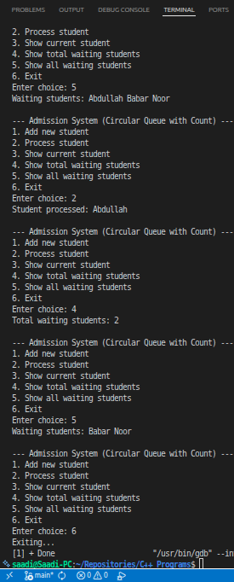
cout << "6. Exit\n";
cout << "Enter choice: ";
cin >> choice;

switch (choice) {
case 1:
cout << "Enter student name: ";
cin >> name;
enqueueC(name);
break;
case 2:
dequeueC();
break;
case 3:
currentStudentC();
break;
case 4:
totalWaitingC();
break;
case 5:
displayC();
break;
case 6:
cout << "Exiting...\n";
break;
default:
cout << "Invalid choice\n";
}
} while (choice != 6);

return 0;
}

